Complete Guide to "XrayGPT" Paper

1. BACKGROUND & MOTIVATION

The Problem
General VLMs (like GPT-4V) are great at:
- "What's in this image?" → "A cat on a sofa"
- "Describe this photo" → "A sunny beach with waves"
But they SUCK at medical images because:

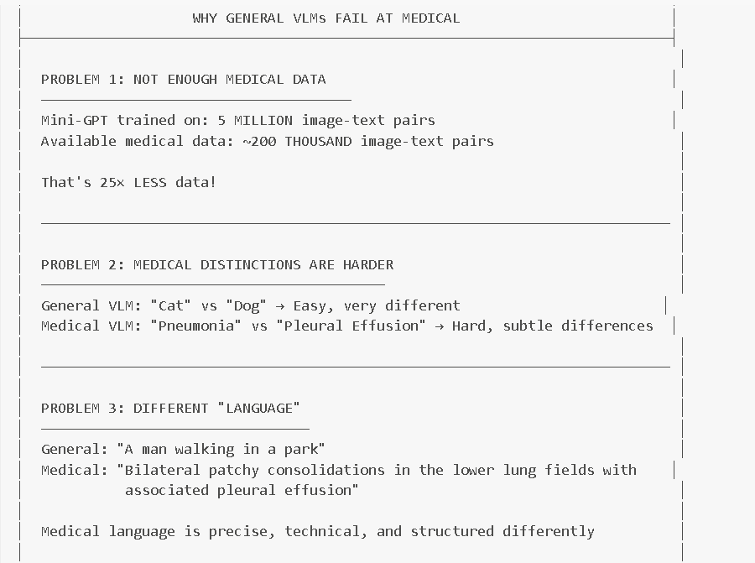

Why Chest X-rays Specifically?
- Most common medical imaging test worldwide
- Critical for diagnosing: pneumonia, heart failure, lung cancer, etc.
- Radiologists write reports → natural image-text pairs exist!
- High clinical impact if we can automate/assist this

2. WHAT IS XRAYGPT?

One-Sentence Summary
XrayGPT is a medical vision-language model that can look at chest X-rays and have conversations about them, like a virtual radiologist assistant.

What Can It Do?
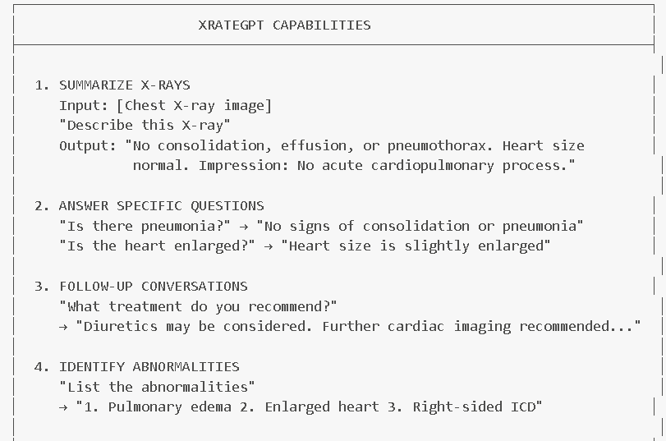
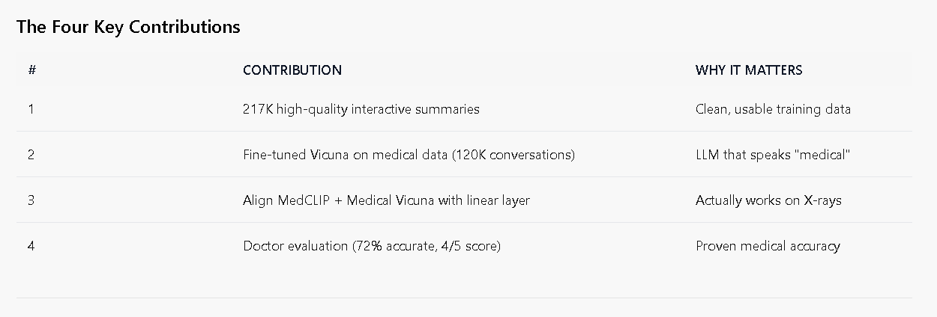
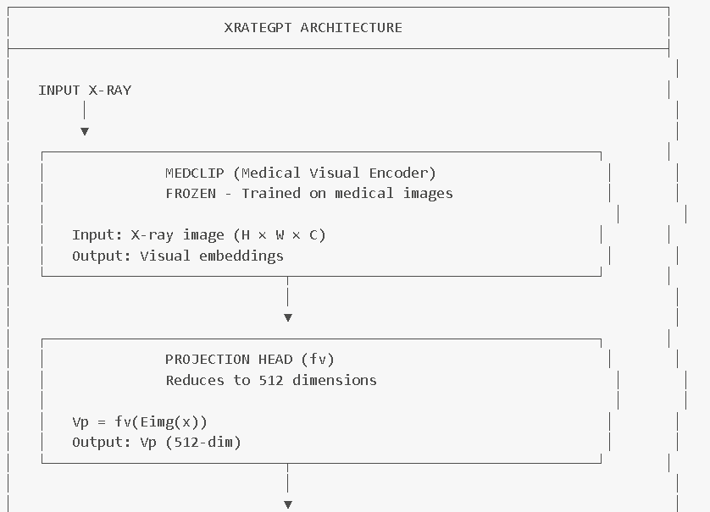
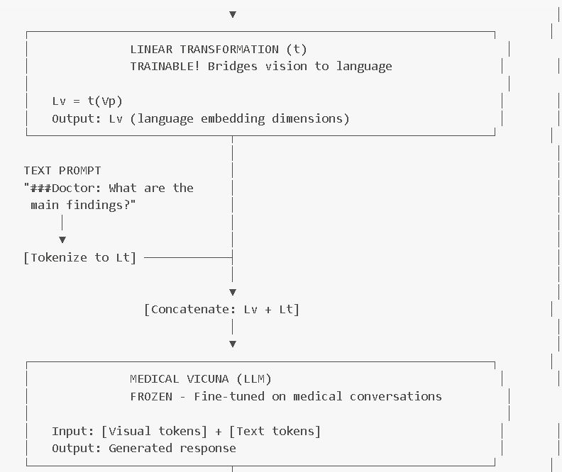
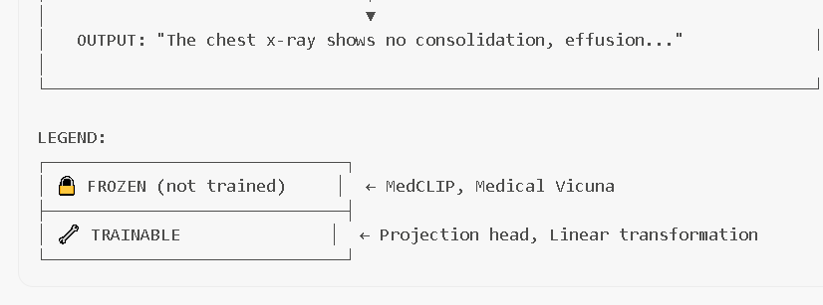

Component 1: MedCLIP (Medical Visual Encoder)
What is it?
- A CLIP model trained specifically on medical images
- Knows medical terminology and visual patterns
Why not regular CLIP?
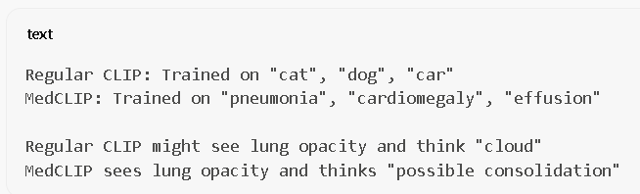
What it does:
- Takes X-ray image
- Outputs visual embeddings (high-dimensional vectors)
- These embeddings contain medical visual information

Component 2: Projection Head (fv)
What it does:
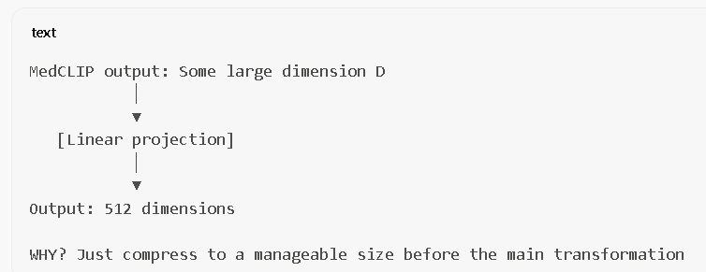

Component 3: Linear Transformation (t) - THE KEY TRAINABLE PART
This is the ONLY thing trained for X-ray understanding!
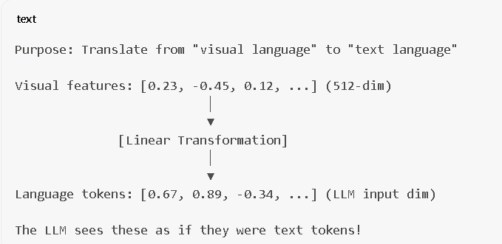
Why just a linear layer?
- Simple = fewer parameters = less overfitting
- With limited medical data, complex layers would memorize
- The pre-trained models already know a lot, just need alignment

Component 4: Medical Vicuna (LLM)
What is it?
- Vicuna (a chat-tuned LLaMA variant)
- Further fine-tuned on 120K medical conversations
How it's made "medical":
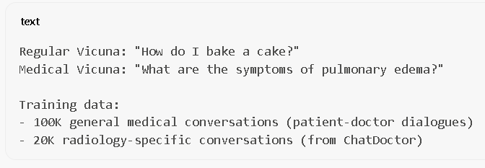
Why fine-tune the LLM at all?
- Regular Vicuna doesn't know medical terminology
- Might say "the image looks cloudy" instead of "lung consolidation"
- Fine-tuning teaches it to speak like a doctor

4. DATA CURATION (IMPORTANT!)

Why Data Curation Matters
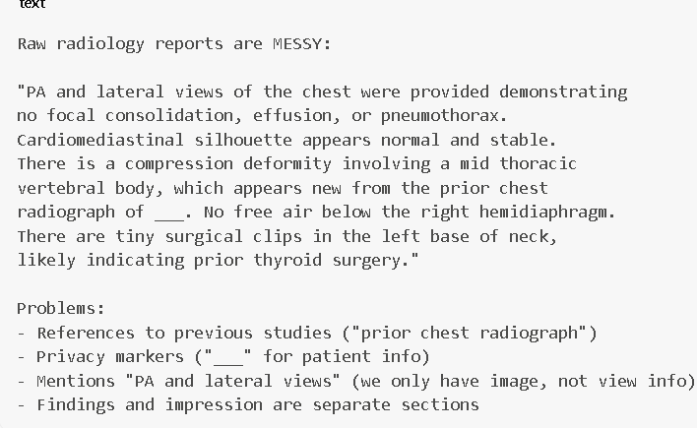

The Cleaning Pipeline
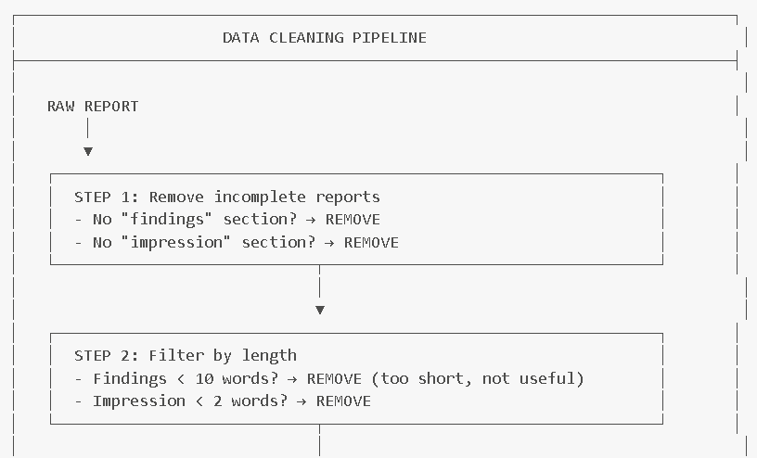
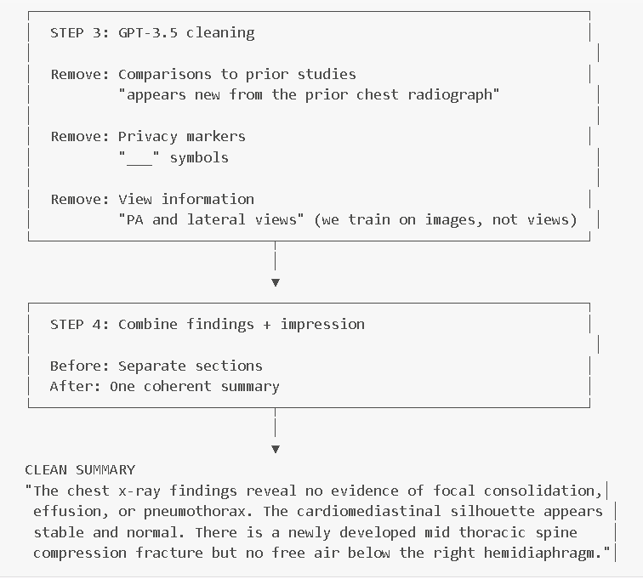

5. TRAINING PROCESS

Two-Stage Training Strategy
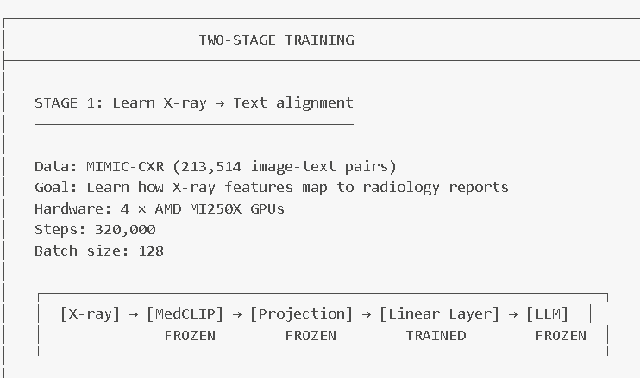
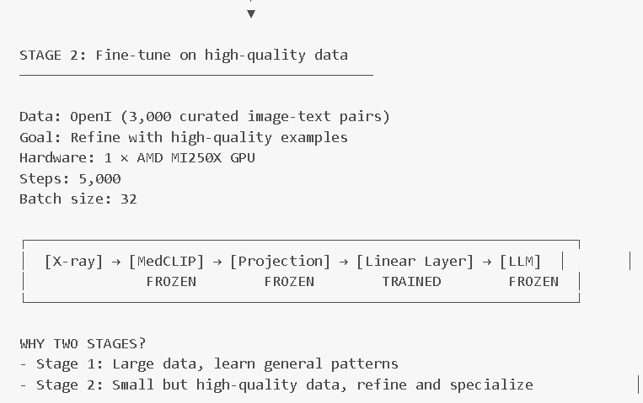

Medical LLM Fine-Tuning (Separate from VLM training)
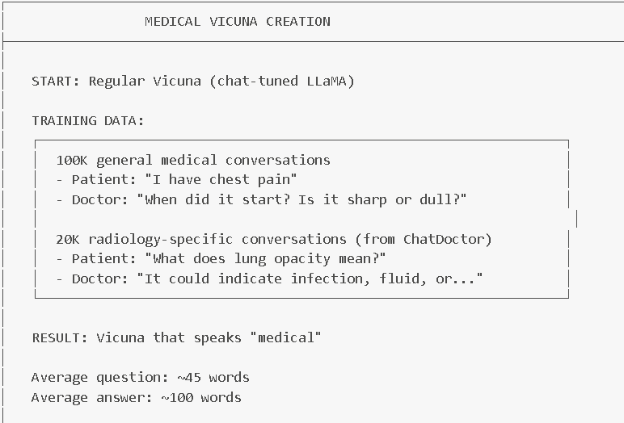
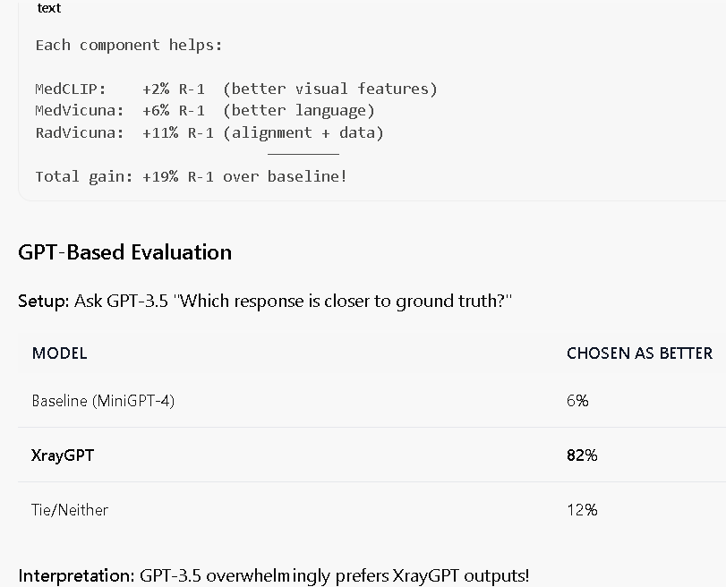

Qualitative Examples (What It Can Do)

Example 1: Basic Summarization

Example 2: Follow-up Question

Example 3: Treatment Recommendation
: Why not use a general VLM like MiniGPT-4 directly? A: (1) Insufficient medical data - general VLMs need millions of pairs, medical data is orders of magnitude less. (2) Medical distinctions are more subtle (pneumonia vs. effusion) than general categories (cat vs. dog). (3) Medical language is different from web text.
Q: What is the role of the linear transformation layer? A: It bridges the gap between MedCLIP's visual embedding space and Vicuna's language embedding space. It's the ONLY trainable component in the VLM pipeline, projecting visual features into tokens the LLM can understand.
Q: Why is the LLM fine-tuned on medical conversations before VLM training? A: Regular Vicuna doesn't know medical terminology. Fine-tuning on 120K medical conversations teaches it to speak like a doctor (e.g., "consolidation" instead of "white spots"). This makes the alignment task easier.
Q: Why clean the radiology reports with GPT-3.5? A: Raw reports contain: (1) Comparisons to prior studies (not in our image), (2) Privacy markers like "___", (3) View information like "PA and lateral" (we only have the image), (4) Separate sections that need combining. Cleaning creates better training pairs.
Q: Why use two-stage training? A: Stage 1 uses large MIMIC-CXR data (213K pairs) to learn general X-ray-to-text alignment. Stage 2 uses smaller but higher-quality OpenI data (3K pairs) to refine and specialize. This prevents overfitting on small data while still benefiting from high-quality examples.
Q: What does 72% accuracy from doctors mean? A: In 72% of evaluated cases, doctors gave XrayGPT a score of 4 or 5 (out of 5), meaning the response was accurate with at most minor false positives. This is significantly better than baseline (20% accurate, score 2/5).
Q: What are the limitations of XrayGPT? A: (1) Struggles with side/lateral views due to training data bias. (2) Only works on chest X-rays, not other modalities. (3) 8% of responses are still inaccurate. (4) May miss subtle abnormalities or provide incorrect treatment recommendations.

